BLACK ROCK

1

NIKAO
31
AVATIU

AVARUA

30 N
PUE

2
3
4 ARORANGI
5
6 2

Cook’s Corner Bus Terminal

MATAVERA

NGATANGIIA

7

8
9 AROA
10
11 12

VAIMAANGA

13

29
28
27
MURI 26
25
24

MOTUTAPU ONEROA KOROMIRI

1 Sunset Resort
2 The Edgewater Resort & Spa
3 Crown Beach Resort & Spa
14 15 16
TITIKAVEKA
17
18 19 20
23 TAAKOKA
22
21

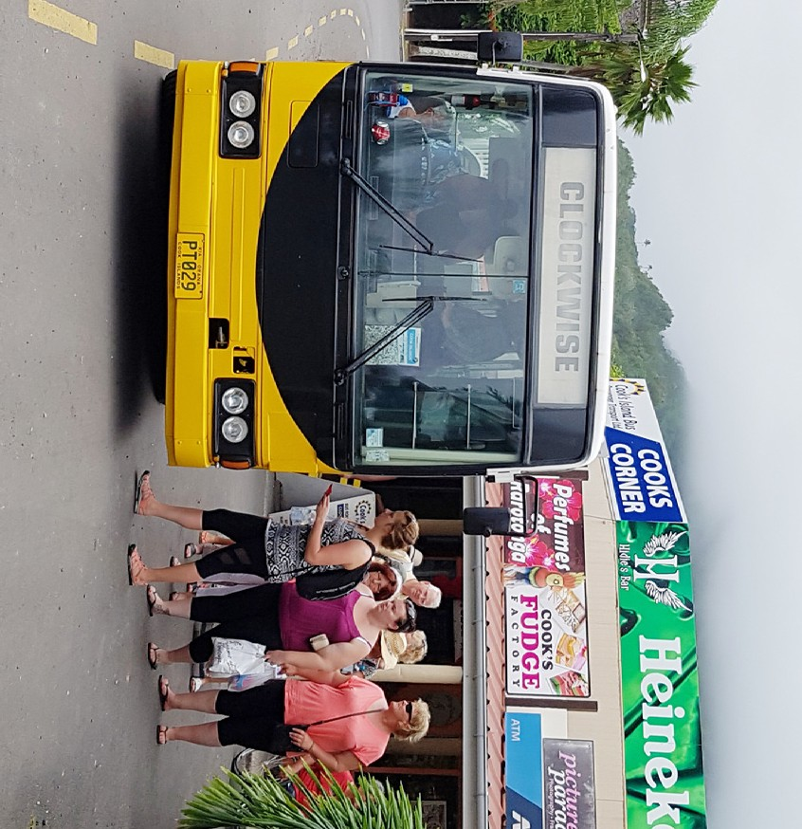
4 Manuia Beach Resort
5 Magic Reef Bungalows
6 Castaway Resort
7 Aro’a Beachside Inn
8 Puaikura Reef Lodges
9 Lagoon Breeze Villas
10 Villa Onemaru
11Kaena Restaurant
12 The Rarotongan Beach Resort & Spa
13 Moana Sands Beachfront Villas
14 Palm Grove
15 Victorias Garden
16 YWAM
17 Sea Change Villas
Bus
Schedule
This timetable is provided with the compliments of
Cook’s Island Bus Passenger Transport Ltd
Visit our Website for more information.
PH: +682 25512 | MOB: +682 55215
E: info@busaboutraro.com
W: www.busaboutraro.com
18 Royale Takitumu
19 Moana Sands
20 Little Polynesian
21 Rumours Luxury Villas & Spa
22 Te Manava
23 Nautilus
24 Muri Beach Resort
25 Muri Beachcomber
26 Pacific Resort
27 Muri Beach Club Hotel
28 Sokala Villas
29 Aroko Bungalows
30 Club Raro
31 Rarotonga International Aiport

Clockwise/Day/Night Schedule Anti-Clockwise Day Schedule
Charges

Bus Stop Mins Past Hour
COOK’S CORNER BUS TERMINAL .................................... 00
Paradise Inn ................................................................... 02
Fishing Club/Club Raro .................................................... 05
Kiikii Motel ..................................................................... 06
Super Brown/Ariana Bungalows ........................................ 07
Matavera Village Traders .................................................. 09
Sunrise Beach Bungalows/Avana Condos........................... 11
Aroko Bungalows ........................................................... 13
Muri Beach Club Hotel..................................................... 14
Pacific Resort................................................................. 15
Muri Beachcomber/Muri Beach/Sails ................................. 16
Muri Beach Resort/Nautilus .............................................. 17
Fruits of Rarotonga ......................................................... 18
Raina Beach Apartments/Charlie’s Cafe.............................. 18
Little Polynesian/Maire Nui Garden .................................... 19
Moana Sands Motel ........................................................ 20
Royale Takitumu Villas/Bella Beach .................................... 21
Sea Change Villas/Saltwater Cafe ...................................... 22
Palm Grove Lodges ........................................................ 25
Wigmore’s Superstore/Waterfall ........................................ 26
Rarotongan Beach Resort/Sanctuary ................................. 30
Lagoon Breeze Villas ....................................................... 31
International Backpackers/Black Pearl ................................ 33
Aro’a Beachside Inn ........................................................ 34
Sunhaven/Rarotonga Backpackers .................................... 35
Castaway Beach Resort ................................................... 36
Manuia Beach Resort ...................................................... 37
Crown Beach Resort ....................................................... 38
Edgewater Resort & Spa.................................................. 40
Sunset Resort/Cook’s Oasis ............................................. 42
Rarotonga Golf Club/Social Centre .................................... 43
21.3 Vaiana’s Bar ........................................................... 44
Rarotonga International Airport/Islander Hotel ...................... 45
CITC Supermarket .......................................................... 48
Punanganui Market ......................................................... 49
COOK’S CORNER BUS TERMINAL .................................... 50

The Clockwise bus departs Cook’s Corner Bus Terminal on the hour, every hour. Monday to Saturday - 7:00am to 11:00pm
Bus Stop Mins Past Hour
COOK’S CORNER BUS TERMINAL .................................... 30
Punanganui Market ......................................................... 32
CITC Supermarket .......................................................... 33
Islander Hotel/Rarotonga International Airport ...................... 35
21.3 Vaiana’s Bar ........................................................... 36
Rarotonga Golf Club/Social Centre .................................... 37
Cook’s Oasis/Sunset Resort ............................................. 38
Edgewater Resort & Spa.................................................. 40
Crown Beach Resort ....................................................... 42
Manuia Beach Resort ...................................................... 43
Castaway Beach Resort ................................................... 45
Rarotonga Backpackers/Sunhaven .................................... 46
Aro’a Beachside Inn ........................................................ 47
Black Pearl/International Backpackers ................................ 48
Lagoon Breeze Villas ....................................................... 49
Sanctuary/Rarotongan Beach Resort ................................. 50
Waterfall/Wigmore’s Superstore ........................................ 53
Palm Grove Lodges ........................................................ 55
Saltwater Cafe/Sea Change Villas ...................................... 58
Bella Beach/Royale Takitumu Villas .................................... 59
Moana Sands Motel ........................................................ 00
Little Polynesian/Maire Nui Garden .................................... 00
Charlie’s Cafe/Raina Beach Apartments.............................. 01
Fruits of Rarotonga ......................................................... 02
Te Manava Villas ............................................................. 02
Nautilus/Muri Beach Resort .............................................. 03
Muri Beachcomber ......................................................... 04
Pacific Resort................................................................. 05
Muri Beach Club Hotel..................................................... 07
Sokala Villas/Kura’s Kabana/Tangaroa Cove ........................ 08
Aroko Bungalows ........................................................... 09
Avana Condos/Sunrise Beach Bungalows........................... 10
Tropical Sands................................................................ 12
Super Brown/Ariana Bunglows.......................................... 15
Kiikii Motel/Club Raro ...................................................... 16
COOK’S CORNER BUS TERMINAL .................................... 20
The Anti-Clockwise Bus departs Cook’s Corner Bus Terminal at
30mins past the hour. Monday to Friday - 8:30am to 4:30pm. Saturdays from 8:30am to 1:30pm.
Fare Type Fare Cost
Adult One Way .......................................................... $5.00
Adult Return.............................................................. $8.00
Child One Way .......................................................... $3.00
Child Return.............................................................. $4.00
Adult 10 Ride Concession......................................... $30.00
Child 10 Ride Concession......................................... $19.00
All Day Pass Single .................................................. $16.00
All Day Pass Family .................................................. $26.00 (2 Adults, 2 Children - 13 under) ..........................................
Tips & Tricks
- To stop the bus, simply stick your hand out and wave out to the driver to stop.
- Let the driver know where you are going when boarding the bus. They will usually remember to stop when they get there.
- If you see your stop coming up, make your way to the front of the bus and gently remind them of your stop.
- It would be to your benefit, the drivers benefit and rest of the passengers if you have the correct change or ticket upon boarding.
- Please wear dry clothing on the bus. They driver may refuse you if your clothing is soaked.
- We encourage all passengers to wear acceptable, decent clothing to avoid offending others.
- Please obey all instructions from the Bus Driver.
- Eating and Drinking on the buses are prohibited.
- Smoking on the buses is strictly prohibited.
- Make sure you have your belongings safely with you before disembarking the bus. Other passengers may not be so honest as to hand it in to the driver if you forget it.
- The driver and/or Cook’s Island Bus Passenger Transport Ltd are not liable for any stolen, forgotten or misplaced items
on the bus. It is your responsibility to look after your belongings.
The Sunday Schedule will operate only from April to November. Clockwise: 8am-12pm then 2pm-4pm. There is no Sunday Anti or Night Bus.
There are no buses operating on Christmas Day, New Years Day and Good Friday (day or night). We have in operation School Buses and Chartered Buses throughtout the year. The Public Buses are clearly labeled “Clockwise” and “Anti-Clockwise”.

